
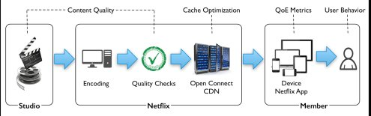
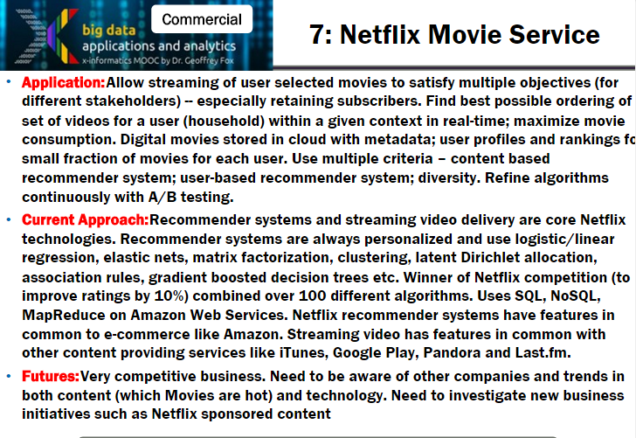
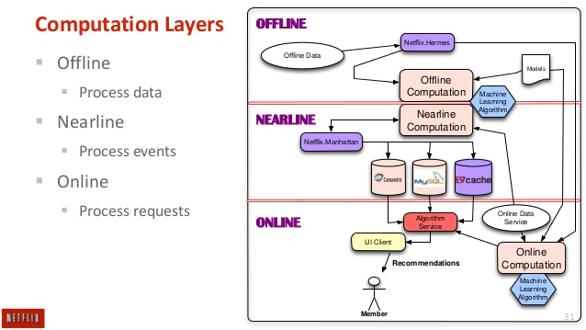
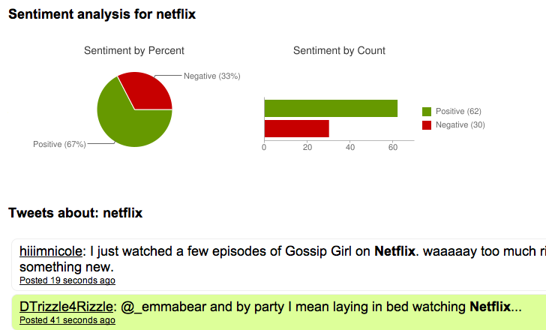
DEPARTMENT OF INFORMATION TECHNOLOGY Experiment No. 7
Semester | B.E. Semester VIII – Information Technology
Subject | Big Data Analytics
Subject Professor In-charge | Prof. Deepali Vora
Assisting Teachers | Prof. Deepali Vora
Laboratory | L11

Student Name | Mehal Chaudhari
Roll Number | 12101A0021
Grade and Subject Teacher’s Signature

Experiment Number | 7
Experiment Title | Case study on Netflix Recommendation System
Resources / Apparatus Required | Hardware: Computer | Software: Java, Hadoop 2.6.0
Objectives  (Skill Set / Knowledge Tested / Imparted) | To study Netflix Recommendation System
Theory of Operation | Introduction:  Netflix is an on-demand provider of hundreds of popular television shows and movies that you can stream. “Streaming” means that you can watch the video file for a movie or TV show as it loads, rather than waiting for it to fully download before you can watch it. With TV, you have to wait for your show to air – or you may have to record it if you know you’ll miss it – but with Netflix, you’re able watch your favorite shows and movies anytime, anywhere.  With a broadband connection, subscribers are able to watch whatever they like, whenever they like, on any Netflix ready device of their choice. Users are able to watch on one device, pause and then continue watching on another device at home or on the go. With the launch, Netflix announced that the service would be available on “smart TVs, tablets and smartphones, computers and a range of internet-capable game consoles and set-top boxes”.  How Netflix uses data science and Big Data analytics to improve the Quality of streaming experience for its members:  On January 16, 2007, Netflix started rolling out a new feature: members could now stream movies directly on their browser without having to wait for the red envelope in the mail. This event marked a substantial shift for Netflix and the entertainment industry. A lot has changed since then. Today, Netflix delivers over 1 billion hours of streaming per month to 48 million members in more than 40 countries. And Netflix accounts for more than a third of peak Internet traffic in the US. This level of engagement results in a humungous amount of data.  At Netflix, we use big data for deep analysis and predictive algorithms to help provide the best experience for our members. A well-known example of this is the personalized movie and show recommendations that are tailored to each member’s tastes. The Netflix prize that was launched in 2007 highlighted Netflix’s focus on recommendations. Another area that we’re focusing on is the streaming quality of experience (QoE), which refers to the user experience once the member hits play on Netflix. This is an area that benefits significantly from data science and algorithms/models built around big data.  Netflix is committed to delivering outstanding streaming service and is investing heavily in advancing the state of the art in adaptive streaming algorithms and network technologies such as Open Connect to optimize streaming quality  Types of problems Netflix solving, which include:  Understanding the impact of QoE on user behavior  Creating a personalized streaming experience for each member  Determining what movies and shows to cache on the edge servers based on member viewing behavior  Improving the technical quality of the content in our catalog using viewing data and member feedback  Understanding the impact of QoE on user behavior:  User behavior refers to the way users interact with the Netflix service, and we use our data to both understand and predict behavior. For example, how would a change to our product affect the number of hours that members watch? To improve the streaming experience, we look at QoE metrics that are likely to have an impact on user behavior. One metric of interest is the rebuffer rate, which is a measure of how often playback is temporarily interrupted while more data is downloaded from the server to replenish the local buffer on the client device. Another metric, bitrate, refers to the quality of the picture that is served/seen - a very low bitrate corresponds to a fuzzy picture. There is an interesting relationship between rebuffer rate and bitrate. Since network capacity is limited, picking too high of a bitrate increases the risk of hitting the capacity limit, running out of data in the local buffer, and then pausing playback to refill the buffer. What’s the right tradeoff?  Improving the streaming experience  The Netflix Streaming Supply Chain: opportunities to optimize the streaming experience exist at multiple points  How do we use data to provide the best user experience once a member hits play on Netflix?  Creating a personalized streaming experience:  One approach is to look at the algorithms that run in real-time or near real-time once playback has started, which determine what bitrate should be served, what server to download that content from, etc.  With vast amounts of data, the mapping function discussed above can be used to further improve the experience for our members at the aggregate level, and even personalize the streaming experience based on what the function might look like based on each member’s “QoE preference.” Personalization can also be based on a member’s network characteristics, device, location, etc. For example, a member with a high-bandwidth connection on a home network could have very different expectations and experience compared to a member with low bandwidth on a mobile device on a cellular network.  Optimizing content caching:  A set of big data problems also exists on the content delivery side. Open Connect is Netflix's own content delivery network that allows ISPs to directly connect to Netflix servers at common internet exchanges, or place a Netflix-provided storage appliance (cache) with Netflix content on it at ISP locations. The key idea here is to locate the content closer (in terms of network hops) to our members to provide a great experience.  One of several interesting problems here is to optimize decisions around content caching on these appliances based on the viewing behavior of the members served. With millions of members, a large catalog, and limited storage capacity, how should the content be cached to ensure that when a member plays a particular movie or show, it is being served out of the local cache/appliance?  Improving content quality:  Another approach to improving user experience involves looking at the quality of content, i.e. the video, audio, subtitles, closed captions, etc. that are part of the movie or show. Netflix receives content from the studios in the form of digital assets that are then encoded and quality checked before they go live on the content servers.  In addition to the internal quality checks, we also receive feedback from our members when they discover issues while viewing. This data can be very noisy and may contain non-issues, issues that are not content quality related (for example, network errors encountered due to a poor connection).  By combining member feedback with intrinsic factors related to viewing behavior, we're building models to predict whether a particular piece of content has a quality issue. For instance, we can detect viewing patterns such as sharp drop offs in viewing at certain times during the show and add in information from member feedback to identify problematic content. Machine learning models along with natural language processing (NLP) and text mining techniques can be used to build powerful models to both improve the quality of content that goes live and also use the information provided by our members to close the loop on quality and replace content that does not meet the expectations of Netflix members.  NoSQL at Netflix  Nosql tool used by Netflix  NoSQL tools: SimpleDB, Hadoop/HBase and Cassandra.  SimpleDB  Amazon SimpleDB was a natural choice for a number of our use cases as we moved into AWS cloud. SimpleDB is highly durable, with writes automatically replicated across availability zones within a region. It also features some really handy query and data format features beyond a simple key/value interface, such as multiple attributes per row key, batch operations, consistent reads.  Hadoop/HBase:  For our systems based on Hadoop, Apache HBase is a convenient, high-performance column-oriented distributed database solution. With its dynamic partitioning model, HBase makes it really easy to grow your cluster and re-distribute load across nodes at runtime, which is great for managing our ever-growing data volume needs and avoiding hot spots  Cassandra:  Use of Cassandra. Distributed under the Apache license, Cassandra is an open source NoSQL database that is all about flexibility, scalability and performance.DataStax, a company that professionally support Cassandra, has been great at helping us quickly learn and operate the system.
Conclusion | Thus we have studied Netflix Recommendation System for movies.

